LabAssignment5
Angelina Podolako s1125886
Radboud University

In this document, you will collect the results of this assignment.:
2. Tutorial 1 2
3. Tutorial 2 – Prototype a game with Generative AI 2
3.1 Part 1 – Make a character move 2
3.2 Introduction to parts 2-4 below 3
3.3 Part 2 – Creating and using textures 3
3.3.1 Using ChatGPT Plus 3
3.3.2 Using Canva 4
3.4 Part 3 – Create a billboard screen 4
3.4.1 Using ChatGPT Plus 4
3.4.2 Using Canva 4
3.5 Part 4 – Create a background screen 4
3.5.1 Using ChatGPT 4
3.5.2 Using Canva 4
4. Requirements 5

2. Tutorial 1
By the end of the Unit, you will be able to call basic functions, then declare and tweak new variables to modify
the results of those functions.
Further, by the end of this Unit, you will be able to:
• Navigate 3D space and the Unity Editor comfortably
• Add and manipulate objects in the scene to position them where you want, including the camera
• Control the layout of Unity Editor to suit your needs
• Create C# scripts and apply them to objects
• Use Visual Studio and a few of its basic features
• Add Rigidbody and Collider components to allow objects to collide realistically
• Declare variables properly and initialize/assign them with appropriate access modifiers

• URL of uploaded game in Unity Play of first tutorial
https://play.unity.com/mg/other/lab5_s1125886_player_control

• C# scripts of first tutorial (FollowPlayer.cs and PlayerController.cs)
PlayerController.cs
using System.Collections;
using System.Collections.Generic;
using UnityEngine;

public class PlayerController : MonoBehaviour
{
private float speed = 20.0f;
private float turnSpeed = 30.0f;
private float horizontalInput;
private float forwardInput;

// Start is called before the first frame update
void Start()
{

}

// Update is called once per frame
void Update()
{
horizontalInput = Input.GetAxis("Horizontal");
forwardInput = Input.GetAxis("Vertical");

// Move the vehicle forward based on vertical input
transform.Translate(Vector3.forward * Time.deltaTime * speed * forwardInput);
// Rotates the vehicle forward based on horizontal input
transform.Rotate(Vector3.up, turnSpeed * horizontalInput * Time.deltaTime);
}
}
FollowPlayer.cs
using System.Collections;
using System.Collections.Generic;
using UnityEngine;

public class FollowPlayer : MonoBehaviour
{
public GameObject player;
private Vector3 offset = new Vector3(0, 5, -7);

// Start is called before the first frame update
void Start()
{

}

// Update is called once per frame
void LateUpdate()
{
transform.position = player.transform.position + offset;

}
}

3. Tutorial 2 – Prototype a game with Generative AI

• For the generative AI tutorial:

o The prompts you used
I used code you provided, because the code from chatGPT did not work for me
using UnityEngine;

public class CharMovement : MonoBehaviour
{
public float walkSpeed = 4f;
public float runSpeed = 8f;
public float jumpHeight = 2f;
public float gravity = -9.81f;
public Transform groundCheck;
public float groundDistance = 0.4f;
public LayerMask groundMask;
private CharacterController controller;
private Vector3 velocity;
private bool isGrounded;

void Start()
{
controller = GetComponent<CharacterController>();
}

void Update()
{
isGrounded = Physics.CheckSphere(groundCheck.position, groundDistance, groundMask);

if (isGrounded && velocity.y < 0)
{
velocity.y = -2f;
}

float x = Input.GetAxis("Horizontal");
float z = Input.GetAxis("Vertical");

Vector3 move = transform.right * x + transform.forward * z;

if (Input.GetKey(KeyCode.LeftShift))
{
controller.Move(move * runSpeed * Time.deltaTime);
}
else
{
controller.Move(move * walkSpeed * Time.deltaTime);
}

if (Input.GetButtonDown("Jump") && isGrounded)
{
velocity.y = Mathf.Sqrt(jumpHeight * -2f * gravity);
}

velocity.y += gravity * Time.deltaTime;
controller.Move(velocity * Time.deltaTime);
}
}
(Code from chatgpt which I have not used:
using UnityEngine;

public class CharacterController : MonoBehaviour
{
public float walkSpeed = 5f;
public float runSpeed = 10f;
public float jumpForce = 10f;

private Rigidbody rb;
private bool isGrounded;

void Start()
{
rb = GetComponent<Rigidbody>();
}

void Update()
{
// Movement
float moveHorizontal = Input.GetAxis("Horizontal");
float moveVertical = Input.GetAxis("Vertical");
Vector3 movement = new Vector3(moveHorizontal, 0f, moveVertical);

if (Input.GetKey(KeyCode.LeftShift))
{
rb.velocity = movement * runSpeed;
}
else
{
rb.velocity = movement * walkSpeed;
}

// Jump
if (Input.GetButtonDown("Jump") && isGrounded)
{
rb.AddForce(Vector3.up * jumpForce, ForceMode.Impulse);
isGrounded = false;
}
}

void OnCollisionEnter(Collision collision)
{
if (collision.gameObject.CompareTag("Ground"))
{
isGrounded = true;
}
}
})

o The associated code or images that you got
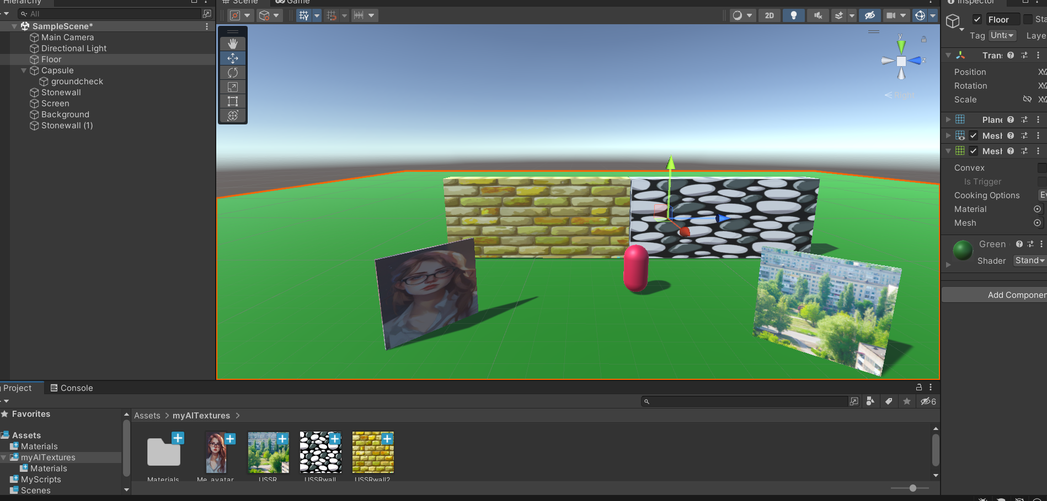
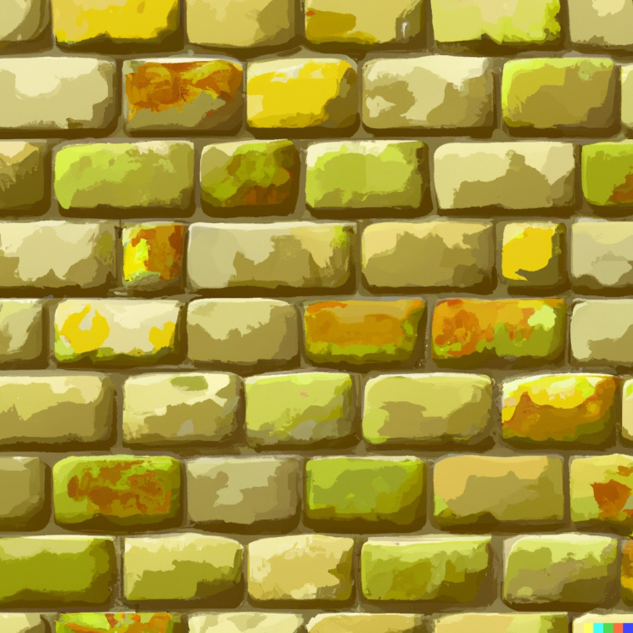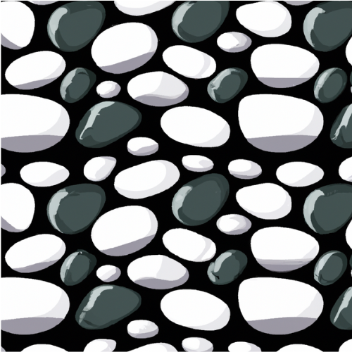

• Write a review of 5-10 lines: what went well with the generative AI, what did not work, what do you

recommend when using generative AI tools for game user interface design
The code could not be generated, there is an assumption that I do not know how to use tags to use his code.

It was also worth pointing out the name of the code to him, otherwise at first the code did not run and I did not understand what the problem was.

It is not so difficult to generate images, but it is worth paying attention in advance to the number of credits remaining. I also didn't understand how to change the photo in the canvas. But I understood how to do it on the site https://openai.com/dall-e-2 .
It is necessary to accept AI errors in the generation of photos.

I recommend generating code using AI only for small items and only if you understand programming, as you will have to fix errors.
Creating textures with AI is a great idea, but it's not suitable for more detailed objects.
I advise future developers to purchase a full (not free) chatgpt. I haven't used it, but I've heard that its features are better than those of free resources.

